CN LAB 7

SALMAN AHMED KHAN 19K-1043

BS SE (A)

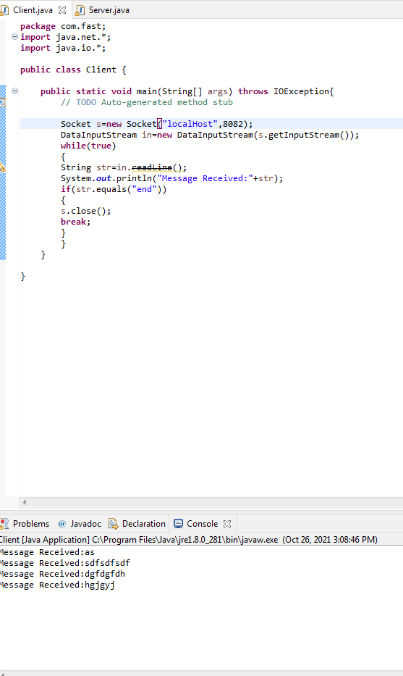

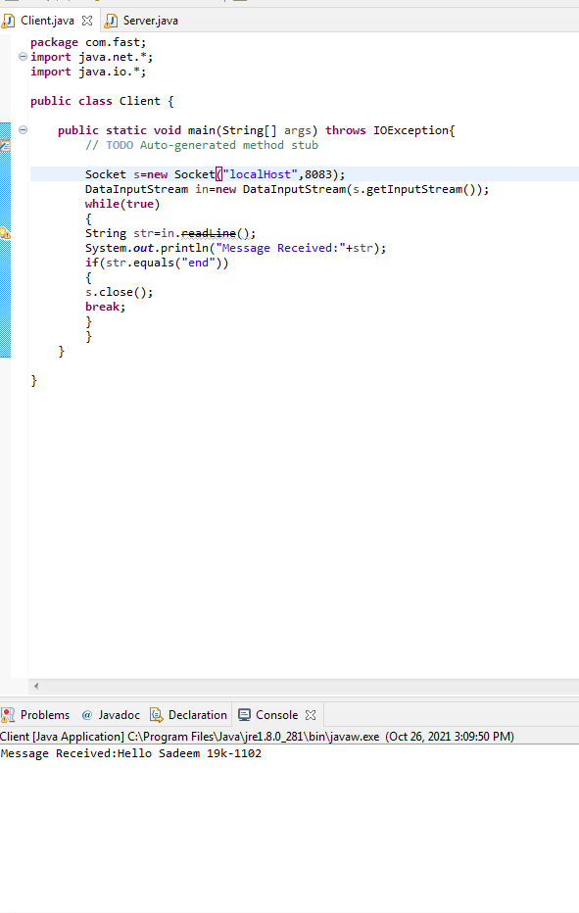

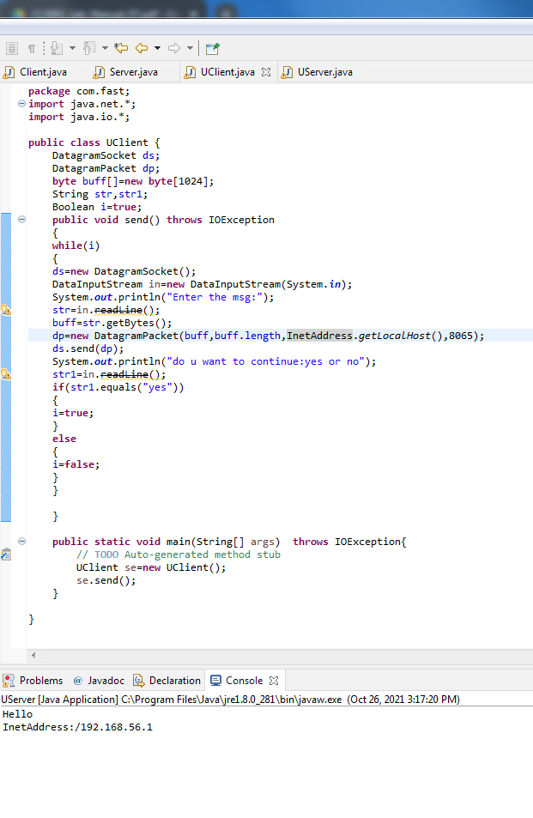

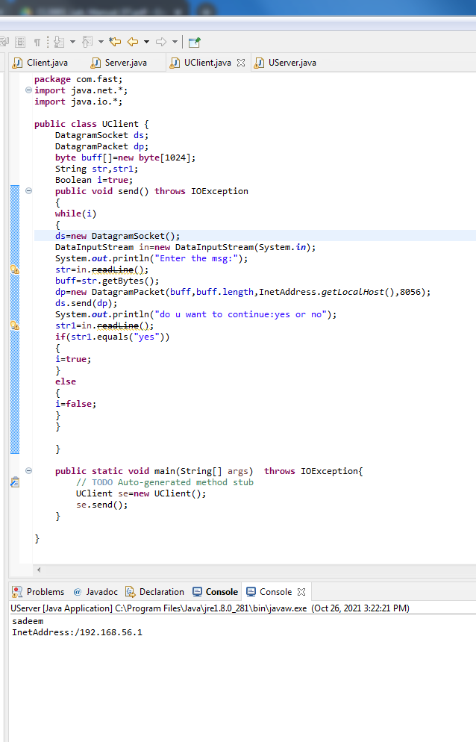

UClient.java

package com.fast;

import java.net.\*;

import java.io.\*;

public class UClient {

DatagramSocket ds;

DatagramPacket dp;

byte buff[]=new byte[1024];

String str,str1;

Boolean i=true;

public void send() throws IOException

{

while(i)

{

ds=new DatagramSocket();

DataInputStream in=new DataInputStream(System.in);

System.out.println("Enter the msg:");

str=in.readLine();

buff=str.getBytes();

dp=new DatagramPacket(buff,buff.length,InetAddress.getLocalHost(),8076);

ds.send(dp);

System.out.println("do u want to continue:yes or no");

str1=in.readLine();

if(str1.equals("yes"))

{

i=true;

}

else

{

i=false;

}

}

}

public static void main(String[] args) throws IOException{

// TODO Auto-generated method stub

UClient se=new UClient();

se.send();

}

}

UServer.java

package com.fast;

import java.net.\*;

import java.io.\*;

public class UServer {

DatagramSocket ds;

DatagramPacket dp;

byte buff[]=new byte[1024];

String str;

public void receive() throws IOException

{

ds=new DatagramSocket(8076);

while(true)

{

dp=new DatagramPacket(buff,buff.length);

ds.receive(dp);

str=new String (dp.getData(),0,0,dp.getLength());

System.out.println(str);

System.out.println("InetAddress:"+dp.getAddress());

}

}

public static void main(String[] args)throws IOException {

// TODO Auto-generated method stub

UServer re=new UServer();

re.receive();

}

}

TCP Client.java

package com.fast;

import java.net.\*;

import java.io.\*;

public class Client {

public static void main(String[] args) throws IOException{

// TODO Auto-generated method stub

Socket s=new Socket("localHost",8083);

DataInputStream in=new DataInputStream(s.getInputStream());

while(true)

{

String str=in.readLine();

System.out.println("Message Received:"+str);

if(str.equals("end"))

{

s.close();

break;

}

}

}

}

TCP Server.java

package com.fast;

import java.net.\*;

import java.io.\*;

public class Server {

public static void main(String[] args) throws IOException{

// TODO Auto-generated method stub

ServerSocket ss=new ServerSocket(8083);

Socket s=ss.accept();

DataInputStream in=new DataInputStream(System.in);

PrintStream dos=new PrintStream(s.getOutputStream());

while(true)

{

System.out.println("enter message to send:");

String str=in.readLine();

dos.println(str);

if(str.equals("end"))

{

ss.close();

break;

}

}

}

}

WireShark

